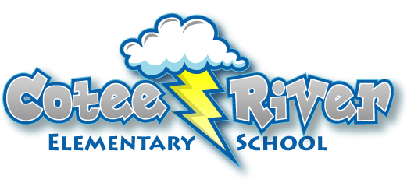

**BOLT POWER HOUR**

Bolt Power Hour is an interactive resource for our parents and guardians. The hour provides our families an opportunity to participate once a month, with their child, in a lively discussion on topics relevant to our school age children, fun-bonding activities, and provides valuable parenting tips you can take home and put to use. Bolt Power Hour also provides an opportunity for our families to network with one another. In addition, breakfast will be provided. Our goal at Cotee River Elementary is to continue to increase our parent involvement and become a valuable resource to our families that reaches beyond the classroom.

Bolt Power Hour meets on the fourth Thursday every other month, please watch for our bi-monthly flyer coming home to reserve your spot. If you have any questions, please contact the front office at 727-774-3000.