**05/01 5th Grade FSA Science Testing Session #!**

**05/02 5th Grade FSA Science Testing Session #2**

05/02 Grades 3-5 Lightning Chorus, 8:30-9:20 am

05/02 Chick-fil-A Family Night, Little Rd., 5:00-7:00 pm (Must bring flyer)

05/04 Grades 1-2 Thunder Chorus, 8:30-9:20 am

05/04 -4th Grade Art Club, 8:30-9:20 am

05/04 Cyber Safety Parent Night, 5:30-6:30 pm

05/05 Special Parts Music, 8:30-9:20 am

**05/05 Field Day (Make sure students bring change of clothes & shoes)**

05/08-05/12 Spring Book Fair, 9:00-3:00 pm

**05/08 Kindergarten Registration, 10:00-1:00 pm**

05/08 Bldg. 6 Great Explorations In-housse Field Trip, 10:30-12:00 pm

05/08 PTA Meeting, 4:15 pm

05/09 Grade 3-5 Lightning Chorus, 8:30-9:20 am

05/10 3r Grade Field Trip, Clearwater Threshers, 9:30-3:00 pm

05/11 Grades 1-2 Thunder Chorus, 8:30-9:20 am

05/11 4th Grade Art Club, 8:30-9:20 am

05/11 PTA Muffins with Mom, 8:45-9:15 pm

05/11 4th Grade Field Trip, Tampa Bay History Center, 10:00-3:30 pm

05/11 5th Grade Field Trip, Astro Skate, 12:00-2:00 pm

05/12 Special Parts Music, 8:30-9:20 am

05/12 5th Grade Starkey Park Field Ttrip, 10:00-1:30 pm

05/12 2nd Grade Parent Involvement Day, 2:15-3:45 pm

05/15 Grades 2-3 Bike Safety Week in PE

05/15 Spring Production Dress Rehearsal

05/16 Grade 3-5 Lightning Chorus, 8:30-9:20 am

**05/16 Fine Art Show, Media, 5:00-7:00 pm**

**05/16 Spring Production of Annie, 7:00-8:00 pm**

05/17 5th Grade “Book Hook Fashion Show”, 10:30-11:30 & 2:30-3:30 pm

05/18 Grades 1-2 Thunder Chorus, 8:30-9:20 am

05/18 4th Grade Art Club, 8:30-9:20 am

05/18 Volunteer & Community Partners Breakfast, 9:30-10:30 am

05/18 SAC Meeting, Media, 4:15 pm

05/19-05/21 Special Olympics State Summer Games, Disney Wide World of Sports, 10 am

05/19 5th Grade Yearbook Signing & Music, 2:00-3:30 pm

05/20 CRES Night @ Ballpark, Clearwater Threshers vs Lakeland Tigers, 5:00 pm

05/22 Reading Celebration

05/23 Grade 3-5 Lightning Chorus, 8:30-9:20 am

05/23 KG Flying Up Program, 2:00-3:30 pm

05/24 5th Grade Moving On Rehearsal

05/25 Grades 1-2 Thunder Chorus, 8:30-9:20 am

05/25 5th Grade Moving On Celebration, 1:45-3:15 pm

05/25 5th Grade Clap Out, 3:30 pm

**05/26 Last Day of School**



Cotee River Lightning Flash Newsletter

Sharon Slusser Dan Wolfe

Principal Asst. Principal

# May 02, 2017

**UpcomingAugust:**

7/31-8/3 – KG Camp, 9:30-11:30 am

8/10 – Meet the Teacher (Registration),

11:00 am – 4:00 pm

8/14 – 1st Day of School @ 9:40 am

**Lunch With Students –** When parents/family members come eat lunch with their child, in order for a student to invite a friend to join them the parent/family member must be an approved volunteer. The friend joining them must eat the food from the cafeteria. There are picnic benches available on the opposite side of the media center (in the shade).

Cotee River Elementary Business/Community Partners

* All Children’s Hospital
* Chick-fil-A, Little Rd.
* Horace Mann Insurance
* Kwanis of Greater West Pasco
* Marjorie’s Hope
* Martial Smart,
* McDonald’s-HMCC Inc.
* Publix, River Crossing
* State Farm Insurance
* Target #1967, Little Rd.
* The Rotary Club
* Timber Green Helping Hands
* US Marine Corp.
* Walgreens #06886

Thank you for supporting our school!

To become a CRES Business/Community Partner please stop in the Main office or give a call to Ms. O’Brien and she will get you all the information that you will need.

727-774-3002

**Box Tops for Education –** CRES continues to participate in the Box Tops and for Education Programs. Through these programs, we collect box tops and Campbell soup labels UPC codes from participating products to earn money from Box Tops and points from labels. Students can turn in what they have collected in the front office on Wednesday or Friday’s.

**Recycling –** Did you know that CRES has a green dumpster (located at the front of the school along the loop, by the PLACE turn off) where you can donate ANY kind of paper good for for recycling? Help us to help the environment by saving all the paper trash including newspaper, cardboard, and packaging. By placing these items in our green dumpster, you also help CRES earn $$$$! Every little bit helps. Also we have battery recycling drop off next to the dumpster and at the front enterence of the office. We appreciate your support.

**Cotee River Spirit Day –** Every Friday CRES has a Spirit Day and we ask for students to wear their Cotee River t-shirts. If you would like to purchase a school t-shirt for $10.00, please stop in the main office and see Mrs. Glover.

**Art News – Spring Art Show, Fine Arts Night:  Tuesday May 16th 5-7:00 p.m., Media Center**

Most classes will be taking the District Final for Visual Art the week of May 8th.  Some classes will be taking it the following week due to scheduling conflicts.

The Pasco Fine Arts Council has summer arts programs for kids ages 7-12, plus other classes for kids and adults that are scheduled throughout the year.  Please check out their website, pascoarts.org, for more information!

The Spring Art Show is happening on Fine Arts Night, May 16th, from 5-7 p.m.  Students with pieces in the show will get an invitation the week before, but all students and families are invited to attend!  Student art in the show may be taken home that night starting at 6:45.  Items not taken home that night will be distributed during regular school hours during that week.

Art Club had its last meeting the last Thursday in April.  There are no Art Club meetings in May.

**Lightning and Thunder Chorus News -** Please remember that all costumes for our "Annie" play must be approved of and completed by the first of May. . If you do need more time, please see Mrs. Kelberlau or Mrs. Patterson. We also need to know if you are borrowing a costume as soon as possible. Our choruses have been working hard and they're sounding great! Please take note of our dates below:

**Monday, May 15th, 3 pm: dress rehearsal at CRES**

**Tuesday, May 16th, 7 pm: performance at CRES**

If you have any questions, please contact Mrs. Kelberlau or Mrs. Patterson at 774-3000 and thank you!

**Field Day –** Field Day is May 5th be sure to send your child with a change of clothes and a pair of shoes so they will be able to change out of wet clothing and shoes. On Field Day only volunteers that are working will be permitted at Field Day.

**PTA Muffins with Mom –** Be on the lookout for the flyer coming home for Muffins with Mom sponsored by PTA on May 11th. All RSVP’s need to be returned by May 8th.

**CRES Student Council News –** Our Student Council has partnered with the Chamber of Comerce collecting items for care packages being sent over to a unit that was recently deployed. The classroom that collects the most items will receive a pizza party. Mrs. Emert’s first grade class and Mrs. Earle’s fifth grade class are the winners for the pizzas party. Thank you all for your donations.

**Cyber Safety Parent Night –** Flyers went home the week of April 10th for the “Cyber Safety Parent Night” on May 4th from 5:30-6:30 pm at CRES. It is sponsored by Baycare Behavioral Health and CRES. Sharon M. Schmidt, B.S. & Cpl. Alan Wilkett of the County Sheriff’s Office will be our speakers. Please make sure you RSVP back to the school with your flyer or call to let us know you will be attending.

**Kindergarten Registration – May 8th at 10:00-1:00 pm**

***Items needed for Registration are:***

* *Current immunization records –* ***MUST*** *have before first day of school.*
* *Proof of a physical examination dated and signed by a licensed health professional within the last 12 months.* ***– MUST*** *have before first day of school.*
* *Birth Certificate*
* *Social Security number (if available)*
* ***Three forms*** *of Proof of Florida residency (utility bill, lease agreement, water bill, driver license with current address)*
* *Copy of student’s last report card (if applicable)*
* *Legal guardianship records (if applicable)*
* *Students entering kindergarten for the first time must be 5 years of age on or before September 1st.*
* *Pre-kindergarten and Head Start/Early Start programs are available to students who will not make the deadline.*

**Lost & Found –** Our lost and found has become full of sweaters and jackets, please remind you child to stop by and check if they are missing any items. It seems when going out for PE or recess they come off and are forgotten ☺

**CRES Night at the Ballpark –** Saturday, May 20th is going to be CRES night at the Clearwater Threshers game. They will be playing Lakeland Tigrs and game time will be 6:15 pm. Gates will open at 5:00 pm and CRES fammilies will have all you can eat from 5:00-7:30 pm and fireworks after the game. The flyers were sent home on April 26th but if you missplaced it please find a flyer attached to the newsletter. All tickets must be purschased no later than May 15th. Hope to see everyone at the game!!

**2017-2018 Class Placement –** If you have information concerning your child that you would considered in the placement decision-making process, please stop by the front office and pick up the form. All forms must be returned to school by May 19th.

**Clothing Donations Needed –** If you are cleaning out drawers and closets over the spring/summer CRES Clothing Closet is looking for new or gently used clothing for both boys and girls. Sizes ranging from 4 through 16. If you would like to drop them off at the front office anytime between 8:00-3:00 pm Monday through Thursday we would appricate it.

**STEM Fair -** Congratulations to your many students who participated in the Elementary STEM Fair!  It was wonderful to see the excitement your little scientists displayed in presenting their projects during interviews with judges and talking with other students.  We also appreciate all of those who helped make this day a success. CRES students were: 2nd place: Savanna Owen, Grace Medina; 3rd place: Kaylee Gottscho, Jayden Nichols, Shayne Perry, and 4th place: Cayden Woo, Kailee Kreidler. Great Job! We look forward to continuing the Science enthusiasm into next year!

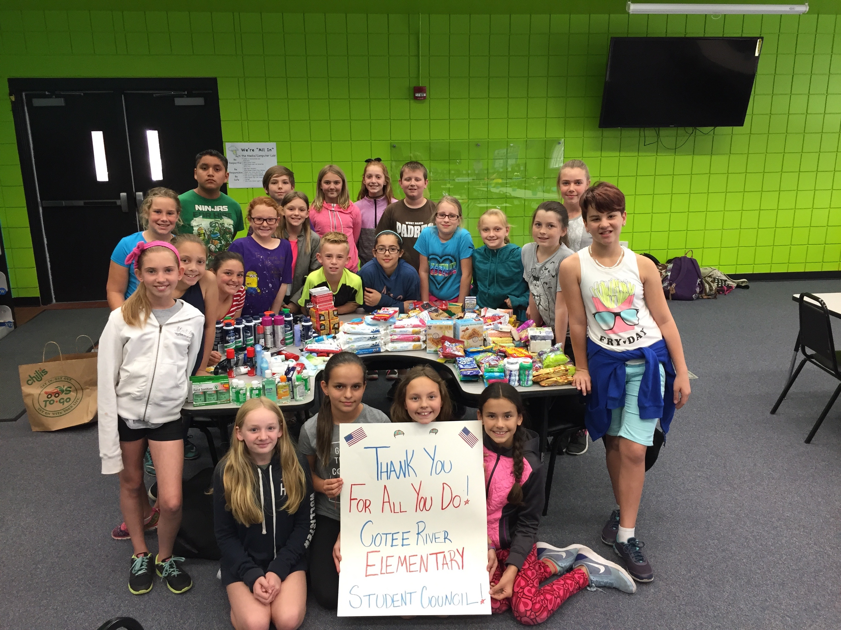

**Student Council News –** Student Council would like to thank everyone donating items for our troops. The Chamber of Commerce picked up the items and they will be shipped to our troops before the end of the month. Thank you again for all your support.

**5th Grade Moving On Celebration –** 5th Graders will be Moving On May 25th at 1:45 pm in the school Café. After the celebration all campus will have a clap out for our 5th graders at 3:30 pm.

