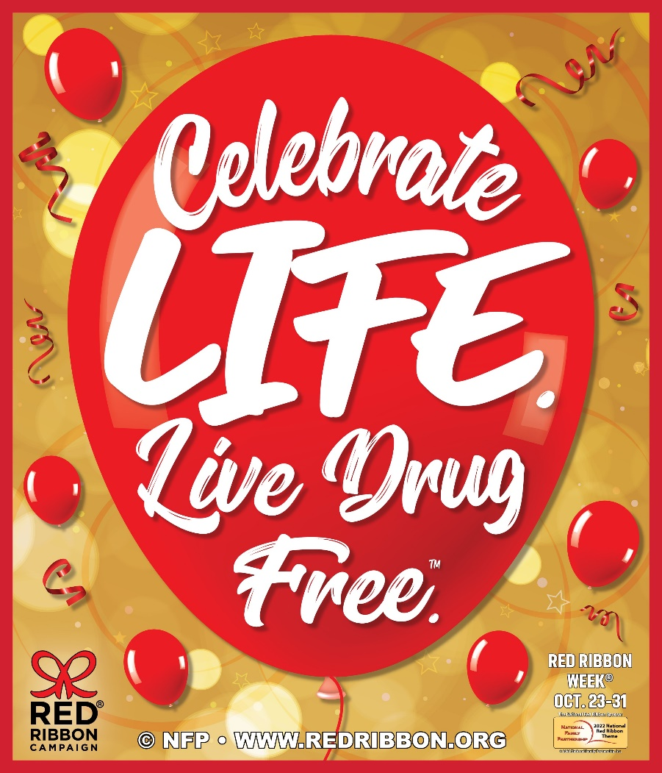

***Red Ribbon***

**Theme Week!**

***Monday 10/24*-** We’re REDy to be drug free! Wear Red day!

***Tuesday 10/25*** Pair up against drugs! TWIN day! Match with a friend.

***Wednesday 10/26-*** Go CRAZY against drugs! It’s crazy hair day!

***Thursday 10/27- “***Sock” it to Drugs! Silly Sock day!

***Friday 10/28-*** We DREAM of a drug free world! Wear your favorite PJ’s!

***Monday 10/31-*** Being drug free takes Character. Dress up as your favorite story book character!

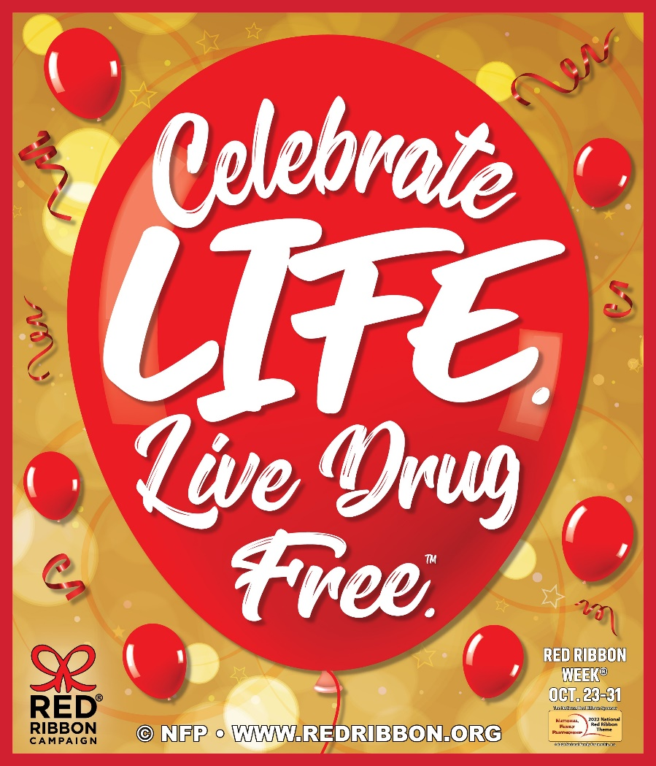

***Red Ribbon***

**Theme Week!**

***Monday 10/24*-** We’re REDy to be drug free! Wear Red day!

***Tuesday 10/25*** Pair up against drugs! TWIN day! Match with a friend.

***Wednesday 10/26-*** Go CRAZY against drugs! It’s crazy hair day!

***Thursday 10/27- “***Sock” it to Drugs! Silly Sock day!

***Friday 10/28-*** We DREAM of a drug free world! Wear your favorite PJ’s!

***Monday 10/31-*** Being drug free takes Character. Dress up as your favorite story book character!