Each Title I school shall jointly develop with parents and family members of participating children, a written plan that shall describe how the school will carry out the requirements mentioned below. Parents shall be notified of the plan in an understandable and uniform format and, to the extent practical, provided in a language the parents can understand. The school plan must be made available to the local community and updated and agreed on by parents periodically to meet the changing needs of parents and the school.

School's vision for engaging families:

Cotee River Elementary School believes parents are the key to the educational success of their children, We see parents as a valuable resource in developing the most effective educational plan for each child. As a school, we strive to be a part of the community and a place where parents are always welcome. We recognize the need to work with parents and families to accomplish our goals of academic achievement and personal growth for each child. Ongoing staff training is critical in us meeting our goals.

What is Required:

Assurances: We will:

Involve an adequate representation of parents, or establish a parent advisory board to represent families, in developing and evaluating the "School Parent and Family Engagement Plan" that describes how the school will carry out its required family engagement activities.

Hold an annual meeting for families to explain the Title I program and the rights of parents to be involved. Offer other meetings/workshops at flexible times.



•CLASS

Use a portion of Title I funds to support parent and family engagement and involve parents in deciding how these funds are to be used.

Involve parents in the planning, review, and improvement of the Title I program.

Develop a school-parent compact that outlines how parents, students, and school staff will share the responsibility for improving student achievement and describes how parents and teachers will communicate.

[Y' Offer assistance to parents in understanding the education system and the state standards, and how to support their children's achievement.

Provide materials and training to help parents support their child's learning at home. Educate teachers and other school staff, including school leaders, on how to engage families effectively.

Coordinate with other federal and state programs, including preschool programs.

Provide information in a format and language parents can understand and offer information in other languages as feasible.

Principal:  Date: 

EVERY TITLE I SCHOOL IN PASCO COUNTY WILL:

1. Involve parents in the planning, review, and improvement of their Comprehensive Needs Assessment and Title I program. The school will jointly develop and evaluate the Parent & Family Engagement plan with an adequate representation of parents.

|  |  |
| --- | --- |
| Describe the method in which parents were involved. | In addition to attending the beginning of the school year annual Title 1 Parent information session, our parents were invited/ encouraged to attend our SAC meetings and Mid- year Parent Input Meeting. We advertise the parent input meeting as well as SAC dates through our monthly newsletter, school website, invitation flyers, Social Media sites such as Facebook and Twitter and displayed on our school marquee. Agendas for SAC are designed to discuss school wide trends (Academic and Social/emotional data), school goals and priorities. Our Parent and SAC meetings allow us to have a focus group to review drafted information and gives feedback prior to completing the final PFEP. In addition, they discuss Title 1 programs and options regarding how the funding will be utilized. Parents also can provide input when developing our PFEP and Compact during our January Parent Input meeting. When input is provided at our meetings, it is documented in our meeting minutes and the PFEP Evaluation template and then shared out with our school-based team. Final copies of the plan are presented with the revisions made.  In addition, parents were provided with a survey in February to collect input on communication, program needs, activities, etc, Also, parent input is provided through a series of focus questions. The feedback is collected, reviewed and action steps are developed. |
| Date of meeting to gather parent input for Comprehensive Needs  Assessment | The gathering of information occurs throughout the school year by our administration and staff during workshops and conferences.  Our Mid -Year Parent Meeting was held on January 30, 2024, with our Sac meeting. We also collected input at our Carline Connection on February 21, 2024. |
| Date of meeting to gather parent input for this Title I Parent and Family Engagement Plan | The gathering of information occurs throughout the school year by our administration and staff during workshops and conferences.  Our Mid -Year Parent Meeting was held on January 30, 2024. The morning meeting coincided with our SAC meeting which allowed for additional input. We also collected input during our Carline Connection on February 21, 2024 |

1. Develop a school-home compact that outlines how parents, students, and school staff will share the responsibility for improving student achievement and describes how parents & teachers will communicate.

|  |  |  |  |
| --- | --- | --- | --- |
| How were parents invited to develop or revise the compact? | Parents were invited by paper invitation, through social media, parent portal Messenger and on the marquee to join us for our Mid-year Parent meeting. During the Parent Input Meeting, A copy of the compact was distributed, verbal feedback was written down on a parent input form and then transferred to a digital copy. | | |
|  | | |  |
| Date of parent meeting to develop or revise the compact | | | January 30, 2024, the morning meeting coincided with our SAC meeting. |
| What communication methods will be used between teachers & parents as well as school & parents? | | | We have a variety of communication methods used to reach our parents. As a school, we use our school marquee, monthly newsletters, school messenger, phone calls, email, social media such as Facebook, our CRES website, flyers, SAC/PTA meetings, parent workshops and family events. Our teachers use planner notes, Mystudent messages and phone calls to reach their parents. |
| Elementary schools are required to hold at least one face to face conference with parents. Explain your process? | | | Our teachers schedule a minimum of one face to face or phone call conference with their scholar's parent/guardian to discuss academic success/needs, work habits and social/emotional needs when applicable. Teachers and/or teams will schedule additional conferences before, after or during school as needed (based on scholar needs). A parent conference form is completed each time. Open communication between parents via Mystudent messenger and phone calls to provide ongoing progress information at the parents' request. |

1. Hold an annual meeting for families to explain the Title program and the rights of parents to be involved.

|  |  |
| --- | --- |
| What information is provided at the meeting?  How are parents notified of the meeting? | Information provided to families: Parent's Right to Get Involved  What is Title 1 funding  Title 1 funds for current school year How families can get involved School Success Plan/ Shared vision  Celebrations  Assessments being used to measure progress & opportunities.  Curriculum standards and assessments are used to measure student progress.  School Parent Compact  Parent and Family Engagement Plan (PFEP)  Opportunities for parents to provide input on their child's education.  What our mission is as a school.  PBIS/ Conscious Discipline information  Additional questions and/or feedback  Parents are notified through the Newsletter, 1st day of school packet includes title 1 letter and invitation, Marquee, social media and MyStudent. |

|  |  |
| --- | --- |
| Tentative date and time(s) of the Annual Title Meeting and steps taken to plan the meeting | August 2024 Morning and Evening meetings. Communication is sent to families in many ways, 1st day of school packets by flyer, social media platforms, newsletter and MyStudent. Admin will partner with front office and parent liaison to determine the date and time. Flyers will be copied and sorted before the meeting. Title 1 letter/invitation will be prepped and put into first day packets before school begins for the 24/25 school year. |
| How do parents who are not able to attend receive information from the meeting? | Information, which includes the Title 1 video is uploaded to our school website and is printed in our school newsletter. |
| How are parents informed of their rights? | Parents are informed of their rights through our Annual Title 1 meeting, and information shared out through our school website, school newsletter and SAC committee. tn addition, students bring home, in their first day packets, a title 1 brochure and PFEP Brochure that gives an overview. Families who also require a translator are informed of their rights to request assistance for all conferences attended. |

|  |  |
| --- | --- |
| Allocation | Approximately $3,600 |
| Explain how these funds will be used this school year | Resources, incentives, food, workshop/event supplies |
| How are parents involved in deciding this? | Mid-year Parent focus groups, SAC /PTA Monthly meetings, and Surveys |
| How did you document parent input? | Through parent meeting notes, SAC minutes and paper survey results |

1. Identify partnerships that coordinate & integrate Title I and local/federal funds to provide opportunities that encourage and support parents in more fully participating in the education of their children and/or to help support learning at home.

|  |  |
| --- | --- |
| Title Ill-ESOL | ESOL IA's. District ESOL Parent and Family Engagement Teacher Student in Transition Teachers, SIT Liaison, Social Workers |
| Title IX-Homeless |
| Preschool Programs IDEA/ ESE | PreK VE and FDLERS |
| FDLERS, ESE Support Facilitators, ESE IA's, ESE Self-Contained Access Points  ABC funds |
| Migrant |
| Other | Title 1 Funding: 1 ELA Coach, 1 additional day Social Worker, 2-3 ESE teachers, 1  General Ed IA |

1. Use a portion of Title I funds to support parent and family engagement and involve parents in deciding how these funds are used.

|  |  |  |  |  |  |  |  |  |  |  |  |  |  |  |  |
| --- | --- | --- | --- | --- | --- | --- | --- | --- | --- | --- | --- | --- | --- | --- | --- |
|  | |  |  |  | | --- | --- | --- | |  |  |  | |  | uonetsue1J_ | | 110Ae3jodsue1± | | |  |  | |  |  | |  |  | |  |  | |

|  |
| --- |
|  |
|
|  |
|  |
|  |
|  |
|  |
| C  0 0  0 0  C 느 ℃  0 0  C -Q C 그 0 음 ; 戔 薯 耄 茗 들目 ; 뤝 C C Q8 웊 鶯 3 로 들 倒 ℃0 “CO  0 으 C  ℃ C ℃ 0  0 드 c E峀 (0c .으 으 은 0 음 .좋  0 <卜§ 등 §죠 으듬 븛 틓 굟 튪튳 불 § §툐 § 경 斝 § ℃ -Q |
|

0

년)

卜> 꽁 亡 병

0

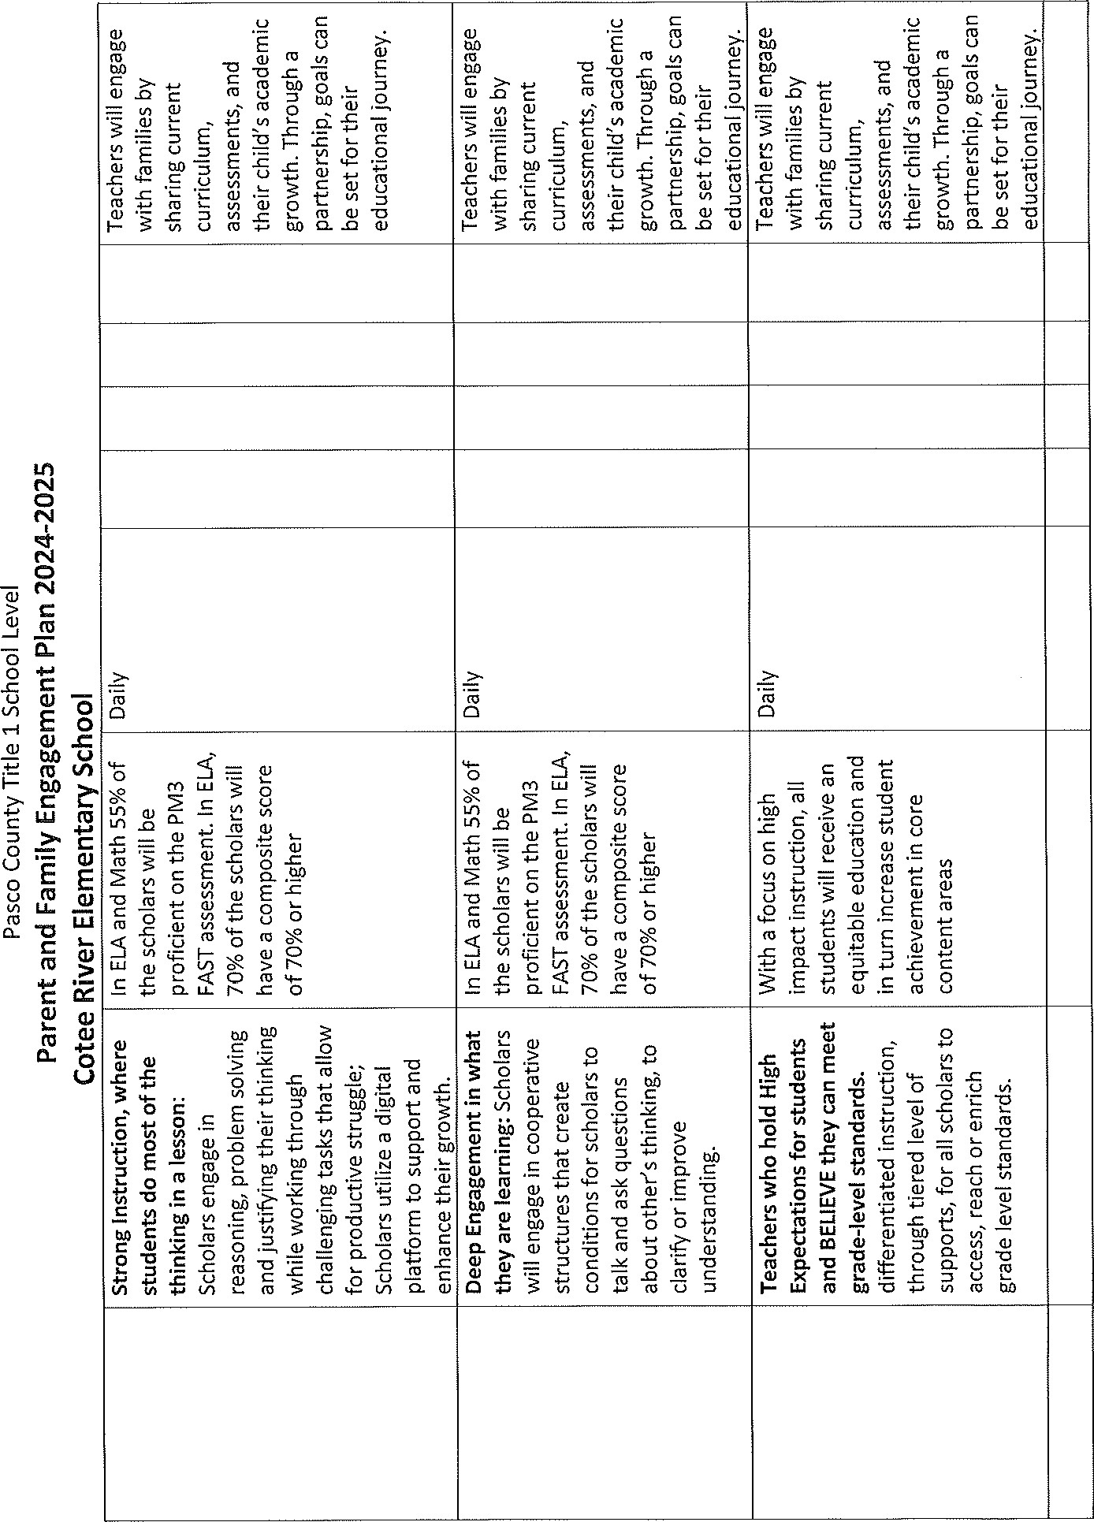

|  |
| --- |
| 0 |
|
|  |
|  |
|  |
|  |
|  |
| 0 0  0  .한 (0 ℃ 邕 8 尹 쓰 예 。 등 包 은 翌岊 둗 § 邕 E ~ = 죠 0 등 은 ℃ 은 •들 = <i• 茗 •眞 은 등 믇 븐 우 8 。 : [ 협 善 룷 茗 ℃倒 : 트 E 끋E C (O  ℃ c 음 혐 & 0 .으 C  그 0 “ 그 E ℃ 工 。 Q 꾣 : k 등 살 틻 돈 5 흠 픧 ℃ •莎  흂 륱 훧 •豈 §  ℃ 0 Q.  등 .읓 8 |
|  |

>

|  |  |  |  |  |  |
| --- | --- | --- | --- | --- | --- |
|  | |  |  | | --- | --- | | 들. :6 E  。 可 드 岧 } E |  | |  |  | |

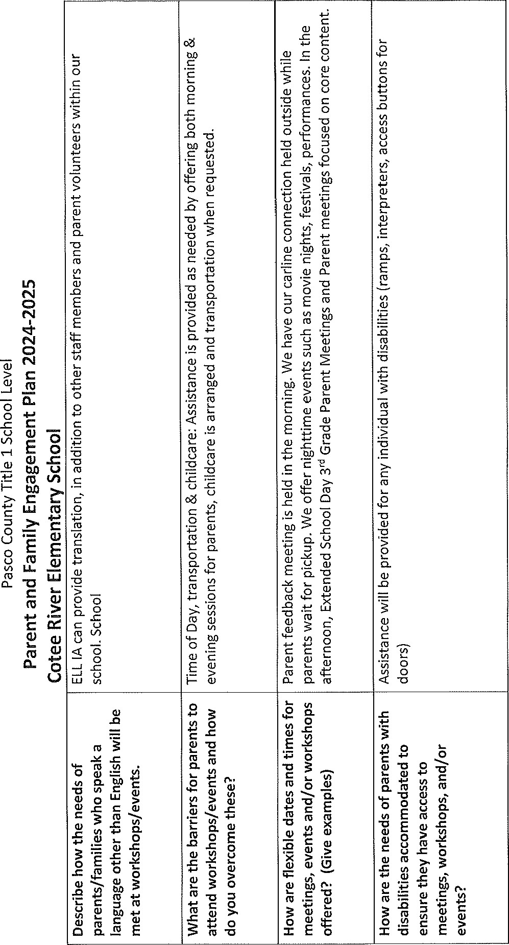

1. Utilize strategies to ensure meaningful communication.

|  |  |
| --- | --- |
| Describe the methods that will be used to ensure meaningful, ongoing communication between home and school. | It is important to the staff at Cotee River Elementary School if parents have any concerns, suggestions, and/or questions regarding our academic programs that they contact us at any time. Parents will be provided information about school programs/events in a variety of ways.  Title 1 Annual Meeting & Open House & Midyear Parent meeting  Monthly Lightning Flash Newsletter (via  Mystudent, posted on school website and social media)  Student Planners/Written Notes  Weekly School Phone calls by administration PBIS positive phone calls home: Bolt of Honor Emails  Parent Conference Notes Parent Teacher Home Visits  School Marquee  School Website  School Flyers  Family Events  Needs Assessment/Parent Survey Feedback  Forms  SAC& PTA Meetings request input in PFEP /compact.  Calendar At a Glance  Cotee River Elementary Social Media accounts: School Facebook and Twitter accounts, As well as the Cotee River Elementary PTA.  Parent Portal  Parent phone calls & Mystudent communication |

1. Educate and build the capacity of school staff on ways in which to work with and engage families effectively as well as the importance of parent engagement in increasing student achievement. Explain your plan for this school year.

|  |  |  |  |  |  |  |  |  |  |
| --- | --- | --- | --- | --- | --- | --- | --- | --- | --- |
| To ic Title | | How does this help staff build school/parent relationships? | | Format for Implementation: workshop, book study, presenter, etc. | | Who is the audience? | | Tentative  Date/Time | |
| Effectively  En a in Families | |  | | Newsletter/ bolt communication. | | All Staff | | Monthly 2024/25 | |
|  | | Will give tips and suggestions on how to increase the relationships with their scholars and their families | |  | |  | |  | |
| Building a    our parents | | Will ive ti s and su estions on how to increase the relationships with their scholars and their families | | Newsletter/ bolt communication | | All Staff | | 2024/25 | |
|  | | Will give tips and suggestions on how to assist parents with the tools needed for them to continue learning at home. | | Newsletter/bolt communication | | Instructional  Staff | | Monthly 24/25 | |

1. Provide an easily accessible resource area where parents and families can get information about the school facility, school policies, contacts, academic assistance, community resources and other materials.

|  |  |  |
| --- | --- | --- |
| Location of Resource Center Area | Person responsible for monitoring and updating Resource Center/Area | List a sampling of materials made available in the Resource  Center/Area |
| CRES front office and within the parent involvement office | Administration, Principal Secretary, SWAT TEAM, Guidance and Compliance Coordinator | PFEP brochures, Title 1 information, ABC paperwork, Parent Portal information, pack a Sack paperwork, local agencies to support student success, SAC/PTA brochures, SIT information, PBIS brochure,  Place program, Parent  Engagement Binder, Computer and printer for parents to use, Family books and resources to help educate on varies topics. |

Principal:  Date: 

Dra ts o PFEP's are due in Title I Crate b A ril 15 2024.

*PFEP Copies should be placed on the school website as well as in the Title I Family and Ccnnmunity Binder in the front office for parent and community access. Infonnation regarding where the plan may be accessed should be comtnunicated to parents and the comtnunity. A "FcnniIy Friendly" version of this plan should be distributed to families.

(7/21/22)