Please Join us!  Cotee River Elementary will host the following events to build capacity for strong family engagement to support a partnership among the school, parents, and the community to improve scholar academic achievement. Family events will be held virtually and/or on campus at varied times to try to accommodate a variety of schedules. |  |  | 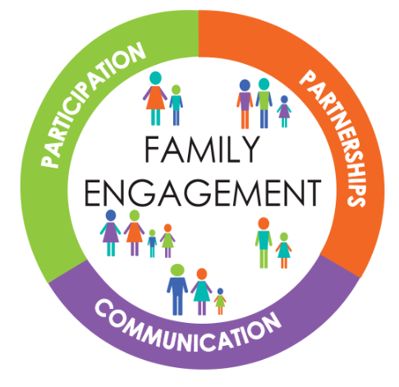  2025-2026  School Success Plan Goals  Visit our Cotee River website, under the school information tab, for our School Success Plan. |  |  | 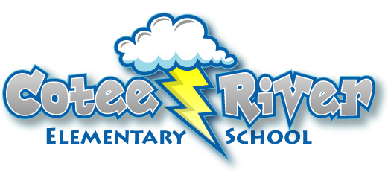  2025-2026  Parent and Family  Engagement Policy and Plan  for Shared Student Success  Belief Statement  Cotee River Elementary School believes parents are the key to the educational success of their children. We see parents as a valuable resource in developing the most effective educational plan for each child. As a school, we strive to be a part of the community and a place where parents are always welcome. We recognize the need to work with parents and families to accomplish our goals of academic achievement and personal growth for each child. Ongoing staff training is critical in us meeting our goals.  What is Title I?  Cotee River Elementary is identified as a Title I school as part of the Every Student Succeeds Act (ESSA). Title I Is designated to support State and local school reform efforts tied to the challenging State academic standards to improve teaching and learning for scholars. Title I programs must be based on the effective means of improving scholar achievement and include strategies to support family engagement. All Title I schools must jointly develop with parents and family members a written parent and family engagement policy.
Annual Title I Meeting- August, 2025
We invite you to a morning of learning and sharing about our Title I Program, including our parent and family engagement policy, schoolwide plan, and the curriculum and assessments used.
Annual Title I Family Input Meeting- January, 2026
Come help us improve by giving your feedback regarding the schoolwide plan, Parent and Family Engagement Plan, School-Parent Compact and the family engagement budget.

Quarterly Coffee Talks- Tools and strategies for parents to use at home that align with school wide commitments and Conscious Discipline practices.

PTA Events- 25/26 school year- Donuts with Dad, Movie Night, Winter Festival, Holiday House, Dance, Bingo night, Muffins with mom.

Curriculum Night- Activities for scholars and parents to work together to complete based on current STEM curriculum within the grade levels.

Bring your Parent/Guardian to school- Each team will invite families in to learn alongside their child each semester. The date, time, and activity will be communicated by your child’s teacher.

Cotee River Elementary is committed to helping our parents and families attend the family activities we offer. Please call or email our Parent Liaison if you need assistance with childcare, transportation, accommodations for a disability, or if you are unable to attend, but would still like to receive event information.
727-774-3000
almiller@pasco.k12.fl.us

We do better when we work together!

How to get involved:
- Join our School Advisory Council
- Join our Parent Teacher Association
- Become an approved Volunteer –https://www.pasco.k12.fl.us/hreq/page/volunteer
Volunteers help with: Events, Chaperone Field Trips, morning carline, read with scholars, library assistance, front office help, special areas (art, music, PE) Etc.
Share Your Thoughts

Have something on your mind? We welcome your feedback! Just call us at 727-774-3000 or email us (www.cres.pasco.k12.fl.us)

School Plan for Shared Scholar Achievement  What is it?  This is the plan that describes how Cotee River Elementary will provide opportunities to improve family engagement to support learning. CRES values the contributions and involvement of parents and family members to establish an equal partnership for the common goal of improving scholar achievement. This plan describes different ways that CRES will support family engagement and how parents can help plan and participate in activities and events to promote scholar learning at school and at home.  How is it revised?  CRES invited all parents to attend our annual Title I parent input meeting last spring to review and revise our parent engagement plan, budget, compact and schoolwide plan. Additionally, parent input and comments regarding this plan are welcome during the school year, please call or email Cotee River Elementary School. All parent feedback received throughout the year and from the parent input meeting will be used to revise this plan for the next school year. We also distribute paper and electronic annual surveys to ask parents for their feedback on this plan and on the use of funds for family engagement.  Who is it for?  All scholars participating in the Title I, Part A program, and their families are encouraged and invited to fully participate in the opportunities described in this plan. CRES will provide full opportunity for the participation of parents and family members with limited English, with disabilities and of migratory children.  Where is it available?  This plan is sent home in the beginning of the year with the Annual Title I letter. It is also available on our website (www.cres.pasco.k12.fl.us) and in the Title I Family and Community Binder located in the parent resource center in Mrs. Miller’s office. Additional copies will be available at the school. |  | Parent and Family Engagement  CRES believes that family engagement means the participation of parents and family members in regular two-way, meaningful communication involving scholar academic learning and other school activities ensuring that:  - Parents play an integral role in assisting their child’s learning in academics and resiliency.  - Parents are encouraged to be actively involved in their child’s education at school.  - Parents are full partners in their child’s education and are included, as appropriate, in decision-making and on advisory committees to assist in the education of their child.  School Parent Compacts  As part of this plan CRES and our families will develop a school parent compact. This is an agreement that parents, teachers, and scholars will develop that explains how parents and teachers will work together to ensure all scholars reach grade-level standards. The compacts will be updated annually based on feedback from parents, scholars, and teachers during the Title I family input meeting. The school-parent compacts also are shared with parents during parent teacher conferences (elementary only).  Parent Resource Center  Our Parent Resource Center is in the front office. There are flyers/applications for school needs, educational materials to assist with at home development and computer access upon request.
Parents as Partners

Cotee River Elementary will take the following measures to promote and support parents and family members as an important foundation of the school. To strengthen the school and reach our school goals. We will…

- Parents will be encouraged to contribute to their child’s education by providing a supportive home environment.

- Parent workshops will be offered at flexible times to assist parents with providing a supportive home environment.

- Parents are encouraged to volunteer and attend school events at Cotee River.

- Parents are invited to participate in parent/teacher conferences on campus or virtually.

- Parents are encouraged to complete school surveys, feedback forms, and join focus groups which help to determine school needs and offerings.

- Parents are invited to scholar recognition activities on campus.

- Parents are encouraged to join our SAC and PTA.

- Parents are encouraged to stay up to date by utilizing our various means of communication such as My Student, newsletters, school wide social media accounts, paper flyers.

“In our school our job is to keep you safe and your job is to help keep it safe”

